**Review Worksheet Answers: DNA sequencing and Protein Electrophoresis**

1: How do nucleotides chemically bind to the one before them as they are added to a sequence by DNA polymerase?

(3 marks)

*They bind to the hydroxyl (OH) group (1) on the sugar molecule (1) of the sugar/phosphate backbone. (1)*

2: Nucleotides are also known as dNTPs in the Sanger sequencing technique. The technique also involves ddNTPs. What is the structural difference between dNTP and ddNTP and what effect does it have on the sequencing process.

(5 marks)

*ddNTPs are modified nucleotides (1) that lack the hydroxyl (OH) group (1). This means that once a ddNTP is added to the sequence (1), no further nucleotides can bind (1), and the strand terminates. (1)*

3: What are the ingredients involved in Sanger DNA sequencing and what is the role of each?

(5 marks)

* *Many copies of the DNA sample of interest, for sequencing (1)*
* *Primer (0.5) to provide a starting point for nucleotide addition to the template strand (0.5)*
* *DNA Polymerase (0.5) to assist with nucleotide addition to the template strand (0.5)*
* *Free nucleotides (dNTPs) (0.5) to be added to the template strand (0.5)*
* *Terminator bases (ddNTPs) (0.5) which terminate the nucleotide addition (0.5)*

4: Four reaction mixtures are set up in Sanger DNA sequencing. Only one ingredient is different in each reaction mixture. Which is it, and why is it different?

(4 marks)

*A different ddNTP or terminator base is added to each reaction mixture (1), one for each base type (1). This means that for each reaction mixture, we know the type of base where the strand terminates (1). This means the sequence can be read after protein electrophoresis. (1)*

5: There are four wells in the electrophoresis gel used for Sanger sequencing. Why are there four wells and how does it help with sequencing?

(3 marks)

*Each reaction mixture is placed in a different well on the electrophoresis gel (1). This means that we know which base terminates the samples in each well (1), allowing the sequence to be read from the smallest strand to the largest. (1)*

6: Describe the steps involved in Sanger sequencing:

(18 marks)

*1: DNA of interest is heated (0.5)so that it is denatured into separate strands (0.5). The template strand will be used. (0.5)*

*2: Primer is added to the template strand (0.5) to provide a starting point for future addition of nucleotides. (0.5)*

*3: Four reaction mixtures are set up, one for each base type. (1)*

*4: Many copies (0.5) of the template strand with the annealed primer (0.5) are added to each reaction mixture (0.5)*

*5: DNA polymerase (0.5) is added to each reaction mixture (0.5) to assist with the addition of nucleotides to the template strand.(0.5)*

*6: Free nucleotides (dNTPs) (0.5)are added to each reaction mixture (0.5) so they can be added to the template strand. (0.5)*

*7: Modified nucleotides / terminator bases /ddNTPs (0.5) are added to the reaction mixtures (0.5). Only one type is added to each reaction mixture (0.5), so each has a ddNTP for one of the four nucleotide types (0.5). These lack the hydroxyl (OH) group (0.5) so no more nucleotides can attach.(0.5) This terminates the chain (0.5) when they are added by the DNA polymerase. (0.5)*

*8: Gel electrophoresis (0.5) is used to separate the different length strands by size (0.5). Four wells are made in the gel (0.5), and one reaction mixture is added to each (0.5). This forms four lanes in the gel (0.5). An electrical current is passed through the gel (0.5). The negatively charged DNA moves towards the positive terminal (0.5). The smaller lengths move faster (0.5), so the strands are organised in size order, in their lanes (0.5). The sequence can then be read by reading from smallest to largest (0.5) across the lanes (0.5), as each strand terminates with the modified nucleotide specific to each reaction mixture. (0.5)*

7: In Sanger sequencing, the terminator base addition determines the length of each strand. Protein electrophoresis is also used for DNA profiling. What is used to break the DNA into short lengths for DNA profiling?

(1 mark)

*Restriction enzymes (1)*



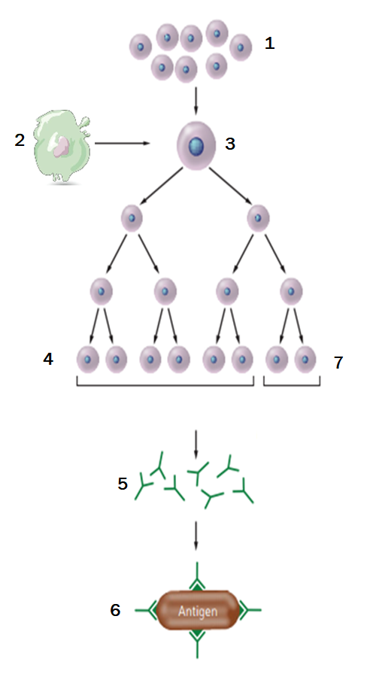8: Name the type of immunity that is occurring in the diagram below and describe what is happening at each step.   
(10 marks of 11.5 marks)

*The flow diagram shows the process of Antibody-Mediated*

*(Humoral) Immunity (1)*

*1: B-lymphocytes in lymphoid tissue (1)*

*2: Antigen Presenting Cell (APC) which has engulfed and*

*destroyed a pathogen (0.5), presents the antigenic site for*

*that pathogen on its surface (0.5).*

*3: The APC presents the antigen (0.5) to a B-cell with a*

*matching receptor (0.5).The B-cell becomes sensitised,*

*enlarges and divides (0.5), producing many more sensitised*

*B-cells. (0.5)*

*4: Most of these sensitised B-cells become plasma cells. (1)*

*5: The plasma cells produce antibody (0.5) specific for the*

*antigen (0.5) originally presented by the APC (0.5).*

*6: The antibody is released (0.5), and is then able to bind to*

*antigenic sites (0.5) on the same pathogens (0.5) as the one*

*originally presented by the APC (0.5), neutralising the*

*pathogens (0.5).*

*7: Sensitised Memory B-cells (0.5) remain in circulation, so that*

*the response proceeds more quickly (0.5) if the pathogen is*

*encountered again. (0.5)*